First and Last Name

9-23-19

Period:____

Q.O.D 9-23 to 9-27

#1

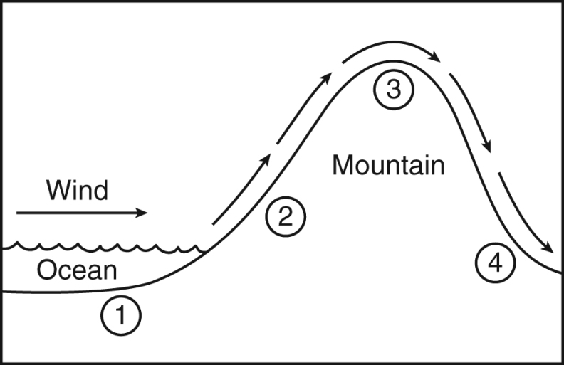

The location with the driest climate would most likely be….

1. 1
2. 2
3. 3
4. 4

Answer: 4

**#2**

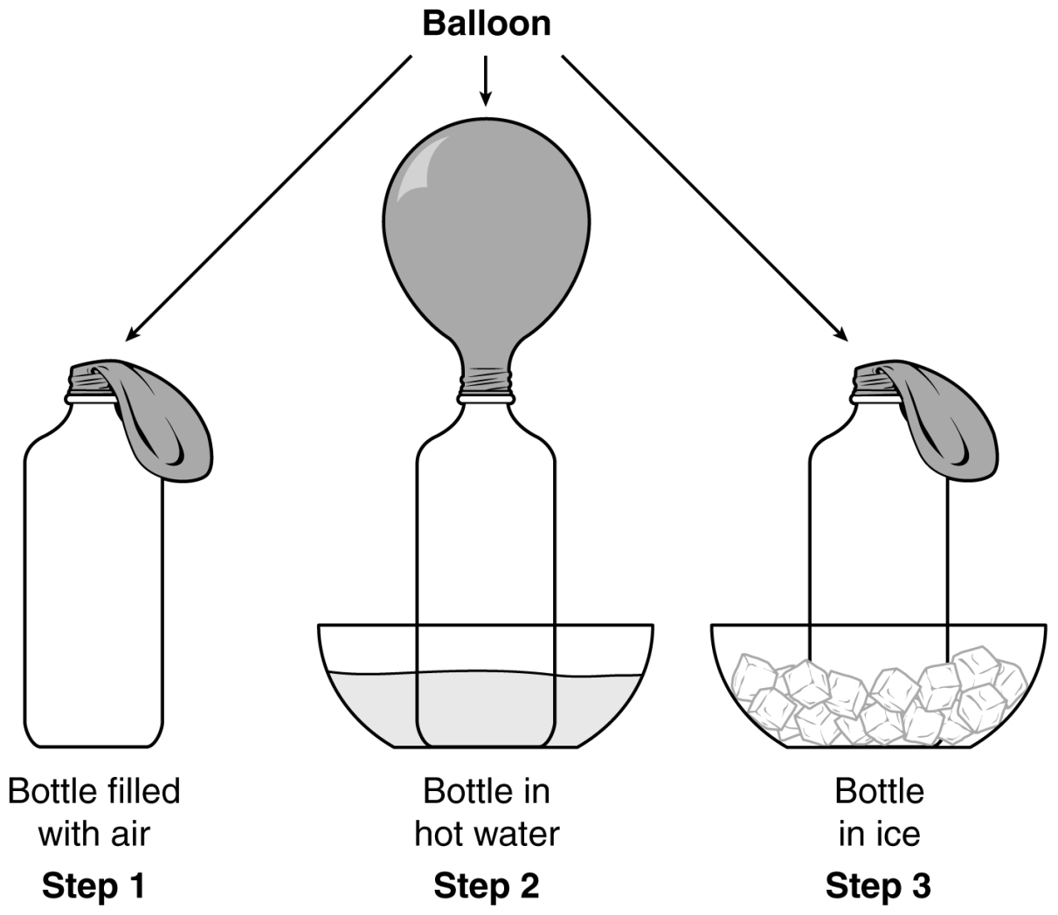

What part of this process is being demonstrated in this diagram?

1. Heat causes gas to expand
2. Heat causes gas to contract

Answer: A

**#3**

Which statement BEST describes the effect of the sun on the oceans?

1. The Sun influences the formation of waves
2. The Sun’s rays causes organisms to form

Answer: A

**#4**

The Gulf Stream travels from the equator toward Europe.

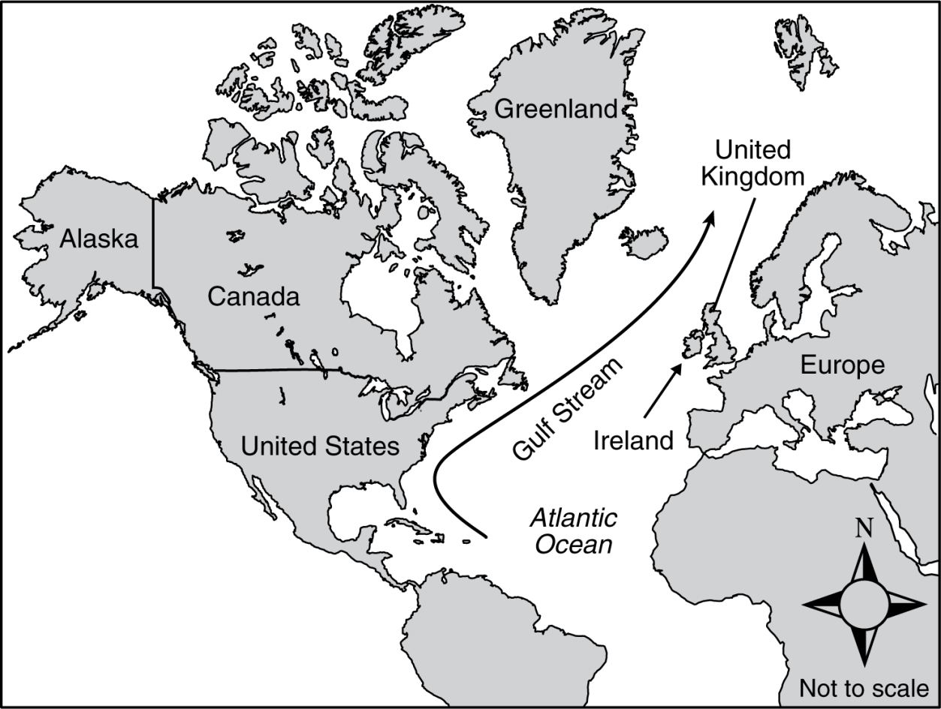

If the Gulf Stream stopped flowing, which environmental change would most likely occur?

1. More reefs would develop in the waters near the eastern Greenland coastline
2. Land masses in the Northern Atlantic oceans would have cooler climates

Answer: B

**#5**

How does the transfer of energy from the Sun to Earth compare with the way energy is distributed in the ocean water?

1. Energy from the Sun is transferred through radiation, while energy in ocean water is distributed by convection.
2. Energy from the sun is transferred through convection, while energy in ocean water is distributed by radiation

Answer: A

Daily Lesson: Mini T